Investigating why large ships float and keys sink?
Experiment 3: Volume & Weight
Which will Sink or Float – Apple v’s a Paperclip
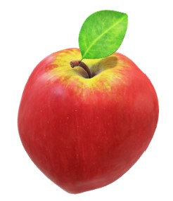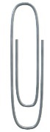

Objective: To determine if the volume and weight of an object affects will cause an object to sink or float

Question: Will an apple or a metal paper clip float in a basin of water?

Materials you will need:

- Worksheet and pen / pencil for recording your results.

- A basin or bowl of Water – hall full.
- Metal paper clip
- Apple

Instructions:

- Analyse and make observations about the apple and the metal paper clip
- Record which items weighs more than the other
- Record which item has more volume
- Predict which item will float and which item will sink
- Place in the basin the apple and metal paper clip into the basin of water
- Record the outcome and interpret the results

Worksheet 3 / Results: Volume & Weight
Which will Sink or Float?

Describe how you analysed the volume and weight of the apple and paper clip.
Observation and analysis of the apple and metal paper clip

___________________________________________________________
___________________________________________________________
___________________________________________________________
____________________________________________________________
The heaviest object is the __________________________.
The lightest object is the __________________________.
The item that takes up the most volume is the ____________________.

____________________________________________________________
____________________________________________________________
____________________________________________________________
____________________________________________________________

Record your prediction of which object will float and which will sink.
My Prediction is

I predicted that the apple will _______________.
I predict that the metal paper clip will ________________.
Why have you made that prediction? ____________________________
__________________________________________________________

Explain the outcome of what happened and explain why.
Outcome – Conclusion to Experiment 3

___________________________________________________________
___________________________________________________________
___________________________________________________________
____________________________________________________________

